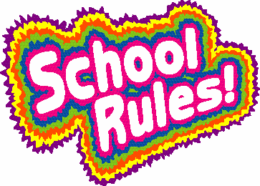Ms. Moorin’s GAT Classroom/Behavior Management Plan

To ensure a safe and effective classroom our rules will be tied to the pillars of character that are taught and reinforced in Bedford County Public Schools (Be Caring, Fair, Trustworthy, Responsible and Respectful).
I will use the balanced GAT approach to reward positive peer interactions with Chilly Chips. When our class has earned 25 Chilly Chips they will have a Go Noodle Dance Party at the end of the day. Students who are struggling with self-control will use the Stop and Stay Cool Strategy and/or move a clothespin from green to yellow to red. They will try to get the clothespin moved back up to green with good choices. If not, I will let you know and they may lose some recess, have silent lunch or see the principal if needed.

GAT is a school-wide conflict-resolution program called Getting Along Together. It helps students with focus, memory, and self-control, as well as building empathy, friendship skills, cognition, and coping skills for common social problems. Teachers use common language, Brain Games and social characters to facilitate students as they participate in classroom discussions and class council meetings. After the first two weeks of daily lessons, GAT begins the regular routine of a skill lesson at the beginning of the week and a Class Council at the end of the week. The Class Council is a meeting in which students celebrate successes and do real-life application of the skills they are learning to create a more positive and productive classroom.

