1st Grade’s Classroom Discipline Policy: Mrs. Richardson’s Classroom
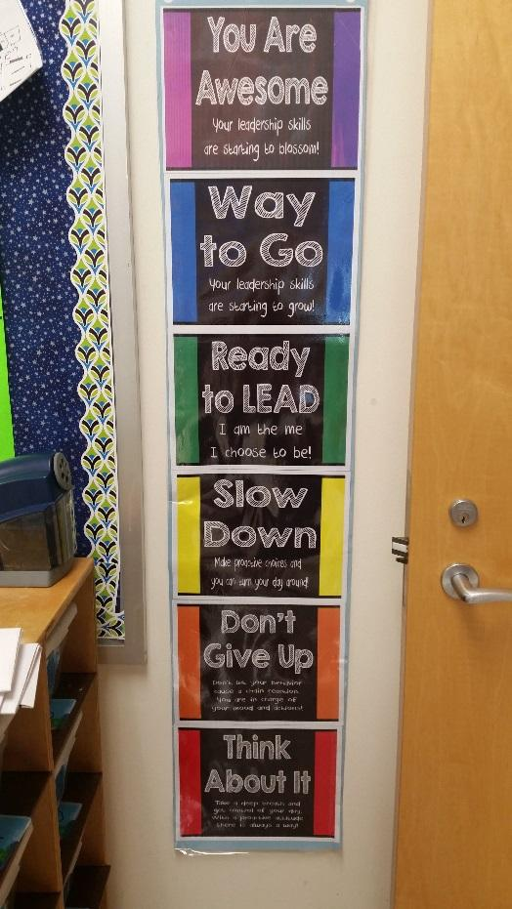
We will be using the Getting Along Together as a schoolwide program this year. Your child will learn teamwork and how to identify and express feelings appropriately, while learning to resolve conflicts in a positive manner and to see situations from another person’s point of view. We will create rules together to follow throughout the school. We will focus on a positive behavior plan that uses a clip system. The students have a clip with their names, and it can be moved throughout the day. Everyone begins the day on green, which means ready to lead. Students who go above and beyond may move up to blue, way to go, (Your leadership skills are starting to grow.), or purple, which is you are awesome, (Your leadership skills are starting to blossom.) If students need reminders their clips might move down to yellow, which is slow down, (Make proactive choices, and you can turn your day around.) If the student is still struggling and needs more time, he or she may move their clip to orange, which is don’t give up. (Don’t let your behavior cause a chain reaction. You are in charge of your mood and actions. The last step on the clip system is red, Think about it. (Take a deep breath and get control of your day with a proactive attitude there is always a way). A behavior calendar will be located in the BEE folder. Please initial this nightly when you sign the reading log. The students will color in where they landed at the end of the day. When students have a problem, we will also implement these other strategies: taking a break, conflict resolvers, cool down strategies, and or the peace path within our classroom.

